Eagle Expectations
SMILEY  EAGLES | Cafeteria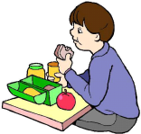 | Hallway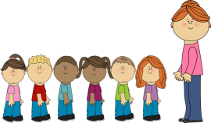 | Playground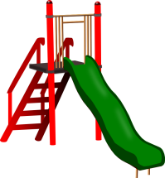 | Restroom | Classroom | Bus  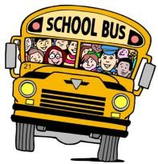
Be Safe | Seat to Seat | Walk on  Smiley Road | Use  Equipment  Properly | Hush, Rush,  & Flush | Stay in Your Bubble | Back-to-Back  and  Seat-to-Seat
Be Responsible | Clean Up  After Yourself | Face Forward | Take Turns  & Share | Walk & Wash | Follow Directions & Rules | Stay in Your  Bubble
Be Respectful | Use  Level 0 or 1 Voice | Use  Level 0  Voice | Use  Level 1, 2, or 3  Voice | Use  Level O  Voice | Use  Level 0 or 1 Voice | Use  Level 0 or 1 Voice
Voice Levels: 0=Silent 1=Whisper/Quiet 2=Talking 3=Outside/Loud

